Design

The following are the iterative designs and ideas that were tried, evaluated, and adapted for the project. In order to come up with the best possible design for the project, several ideas were evaluated according to the criteria rubric developed in Project 2.

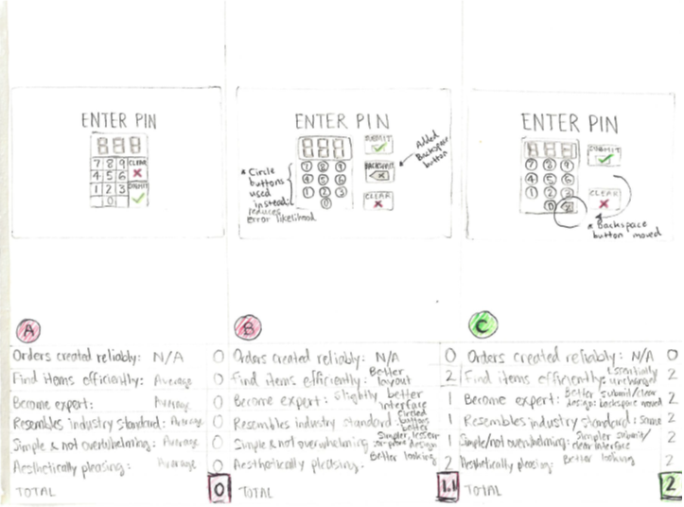

*Figure 1 – Iterative designs for POS terminal log-in screen.*

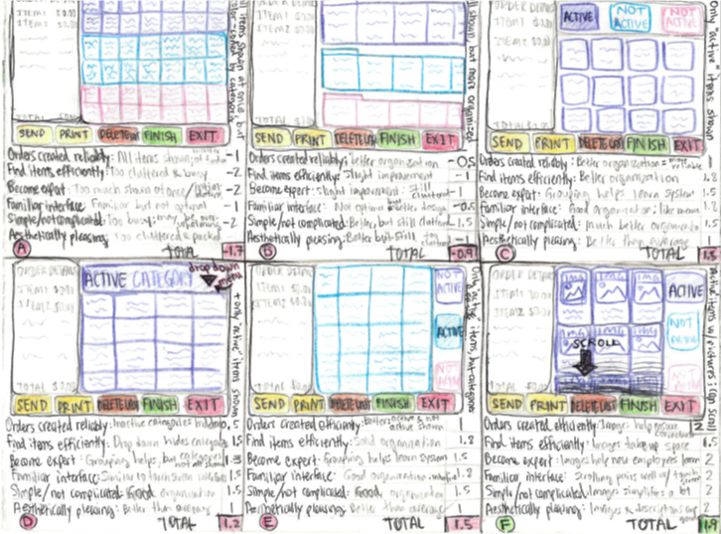

*Figure 2 – Iterative designs for POS terminal order-creation screen.*

Prototype & Working Product

The designs were evaluated according to the criteria rubric developed in Project 2. The best designs were design (C) for the log-in screen and design (F) for the order-creation screen. To demonstrate a prototype, an interactive mockup was created, and a video was posted to YouTube.

Here is the link to the *prototype* demonstration: <https://www.youtube.com/watch?v=6heExsBGhew>

Here is the link to the *working product*: <https://stormy-scrubland-40123.herokuapp.com/>

**Note**: users may log in using any three-digit PIN.

Specification

Table of Contents

Executive Summary 4

Criteria 4

Persona 4

Scenario 5

Prototype 5

Detailed Design 7

Structure: Log-in and Order-creation Screens 7

Details: Log-in and Order-creation Screens 9

*Controls and State for Log-in Screen:* 9

*Controls and State for Order-creation Screen:* 10

Appendix: Change history 12

Appendix: Updated Visuals 13

# Executive Summary

By connecting front and back of house employees with intuitive, easy-to-use technology, our restaurant POS systems enable staff members to reach their full potential as productive, efficient, and caring service-providers.

Tailored to the restaurant industry's needs, our systems improve service delivery by increasing speed of service and reducing errors, thereby giving team members the power to deliver that "*wow*" experience for their guests.

# Criteria

Success can be measured according to the following, prioritized criteria:

|  |  |  |
| --- | --- | --- |
| Priority 1 | Priority 2 | Priority 3 |
| * An employee must be able to locate menu items efficiently | * A new employee should be able to gain expertise with the POS system with relative easy | * The POS system’s layout and appearance should be pleasing to the user |
| * Employees must be able to create and place orders for preparation correctly | * The POS system should bear resemblance to other, standard restaurant industry POS systems and general touch-screen interfaces |  |
|  | * An employee with a sound understanding of the restaurant’s menu should be able to use the system without much trouble |  |

# Persona

A resident of a coastal town in Massachusetts and a 45-year-old mother of two, Angela Smith has been in the seafood restaurant industry since she could remember. Driven by a passion for providing hospitality and warmth to her guests, Angela is an experienced waitress at *The Daily Catch*, a popular, local seafood restaurant, and she looks forward to every shift, where she gets to meet and interact with new people every day.

Angela’s job can be very demanding, however, as *The Daily Catch* strives to give its guests the highest quality of service possible. Although not an avid fan of today’s “gadgets,” Angela is a quick learner and has done a good job of adapting as the restaurant industry has incorporated more technology in recent years.

An essential part of Angela’s job is to use the restaurant’s point of sale (POS) system to ring up orders and process payments. Angela’s job performance relies heavily on efficiency, as she must be able to use the POS system to complete her tasks with as little effort and time as possible.

# Scenario

After making her way over to The Daily Catch, Angela makes it just in time for her shift to begin but arrives to a full parking lot and rushes in. The restaurant is in chaos: they are short-staffed, the lobby is filled with impatient guests, and her coworkers are in a frenzy. Eager to help and begin, Angela quickly clocks in and is soon placed on the floor.

A few minutes elapse and Angela must now use the POS system to place an order. After logging in, with just a few taps and swipes, Angela creates her order and sends it directly to the kitchen. Her experience and familiarity with the system allowed her to do something in under a minute that would have taken a newer employee much longer.

After a while, Angela realizes she forgot to place one of her guests’ appetizer orders! She nearly panics but composes herself and sprints towards the nearest POS system, where she logs in. The appetizer is a new, seasonal item, and Angela cannot seem to find it in the system. A few frustrating seconds go by, and Angela realizes the new item is likely under the “Promos & Specials” section of the system’s menu. She navigates her way towards the section and quickly looks for it. After locating it, it takes just a few taps to be able to add the new item to the order and send it through to the kitchen: crisis averted!

# Prototype

|  |
| --- |
|  |

*Figure 3 - POS terminal log-in screen.*

|  |
| --- |
|  |

*Figure 4 - POS terminal order creation screen.*

|  |
| --- |
|  |

*Figure 5 - POS terminal order creation screen.*

# Detailed Design

## Structure: Log-in and Order-creation Screens

|  |
| --- |
|  |

*Figure 6 – Structure of POS terminal log-in screen.*

|  |
| --- |
|  |

*Figure 7 – Structure of POS terminal order-creation screen.*

## Details: Log-in and Order-creation Screens

### *Controls and State for Log-in Screen:*

|  |  |  |  |
| --- | --- | --- | --- |
| Name | Description | Active (pressed) | Inactive |
| Keypad Input – Number | Number keyed by user |  |  |
| Keypad Input – Backspace | Deletes last entry |  |  |
| Submit Input | Submits input |  |  |
| Clear Input | Clears Input |  |  |
| Keypad Output | Displays input |  |  |

### *Controls and State for Order-creation Screen:*

|  |  |  |  |
| --- | --- | --- | --- |
| Name | Description | Active (pressed) | Inactive |
| Order Input – Item Category | Category of food for item |  |  |
| Order Input – Order Management | Order creation functionality |  |  |
| Order Output – Order Summary | Displays items currently on order |  |  |
| Items for Category | Displays items within food Category |  | Blank screen. |

# Appendix: Change history

|  |  |
| --- | --- |
| Date | Change |
| 2/17/2010 | Initial Design, Prototype, and Specification document completed |
| 3/5/2018 | Implemented functionality of login page with rough graphics |
| 3/6/2018 | Implemented limited functionality of order-creation page with rough graphics |
| 3/7/2018 | Implemented working functionality of order-creation page with rough graphics |
| 3/7/2018 | Set up Heroku database for application |
| 3/7/2018 | Populated database with various menu items |
| 3/9/2018 | Changed login "Enter Pin" font family to Poppins |
| 3/9/2018 | Changed login pin “Submit” button font family to Calibri |
| 3/9/2018 | Changed login pin “Clear” button font family to Calibri |
| 3/9/2018 | Changed backspace arrow to now use Google API material icons |
| 3/9/2018 | Changed color of keypad from orange to light gray |
| 3/10/2018 | Changed rounded edges of Submit and Clear buttons |
| 3/10/2018 | Changed pin output font family to Poppins |
| 3/17/2018 | Changed rounded edges for all buttons in order creation page |
| 3/17/2018 | Changed heading in order summary portion of order creation page to read “Order Summary” instead of “Order Details” |
| 3/17/2018 | Changed font family for order summary to Calibri |
| 3/17/2018 | Added item description (e.g. “Qty,” “Item name,” “Price”) below order summary header in order summary portion of page |
| 3/19/2018 | Gave menu item images rounded edges |
| 3/19/2018 | Replaced item description in image cards with item prices |
| 3/20/2018 | Made total and price font weights bold in order summary portion of page |
| 4/12/2018 | *Response to Usability Study Recommendation #2 and Ponder 11 Project Evaluation (Criteria: Standards-Color)*: Updated stylesheet and PHP and JavaScript files to allow alternate way to highlight the currently selected tab. Now not “graying out” inactive buttons; rather, a red border is used to indicate active menu category; in direct response to Usability Study Recommendation #2. |
| 4/12/2018 | *Response to Ponder 11 Project Evaluation (Criteria: Standards-Layout)*: Reversed first and third columns (Order Summary and Menu Categories) to enhance reading order to left-to-right. |
| 4/12/2018 | *Response to Ponder 11 Project Evaluation (Criteria: Standards-Typography)*: Updated font family of  Order Summary from sans to san-serif font. |
| 4/12/2018 | *Response to Ponder 11 Project Evaluation (Criteria: Overall)*: Updated overall design to benefit from more consistent grid layout by improving margins between items on page. |
| 4/12/2018 | *Response to Ponder 11 Project Evaluation (Criteria: Overall)*: Updated overall design by removing most pronounced the black lines previously used for grouping. Now achieving same effect by handling by using more visually appealing light gray, dashed borders, removing borders altogether (see Updated Visuals or Updated Project website). Removed border for Menu Category buttons altogether to convey better sense of grouping with actual menu items. |

# Appendix: Updated Visuals

|  |
| --- |
|  |

*Figure 8 – Updated POS terminal log-in screen.*

|  |
| --- |
|  |

*Figure 9 – Updated POS terminal order creation screen.*

|  |
| --- |
|  |

*Figure 10 – Updated POS terminal order creation screen.*

Rubric

|  |  |  |  |  |  |
| --- | --- | --- | --- | --- | --- |
|  | Exceptional 100% | Good 90% | Acceptable 70% | Developing 50% | Missing 0% |
| Final Project 30% | This is a runaway success | The project is likely to meet all the needs of the target user | Minor defects remain in the project | Serious defects remain in the project | No final project |
| Spec 10% | There is no difference between the design in the spec and the final project | The spec is updated with the latest visuals | Minor inconsistencies exist in the spec | The spec appears unchanged from Project 3 | No final spec |
| Usability Study Response 60% | Every issue was addressed in the best possible way | Every issue was addressed, but the rational for some of the changes could be improved | The usability study response document was missing | At least one problem found in the usability study was fixed | It does not appear that any of the problems found in the usability study were addressed |